**Unit Test report**

**Project**: TechNologyOne_Interview **Date**: 24/08/23/ 01:18AM  
**Tester**: Wonwoo Choi

**Summary**

* Total Number of Tests: 8
* Passed Tests: 5
* Failed Tests: 3
* Skipped Tests: 0
* Duration: 0.386190 seconds

First Test

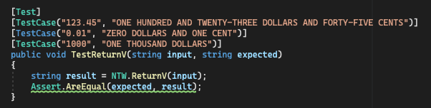

- Status: Failed

- Error:

1.  
Expected: "ONE HUNDRED AND TWENTY-THREE DOLLARS AND FORTY-FIVE CENTS"  
But was: " ONE HUNDRED AND TWENTY-THREE DOLLARS AND FORTY-FIVE CENTS" 2.  
Expected: "ONE HUNDRED AND TWENTY-THREE DOLLARS AND FORTY-FIVE CENTS"  
But was: "ONE HUNDRED AND TWENTY-THREE DOLLARS AND FORTY-FIVE CENTS"  
3.  
Expected: "ZERO DOLLARS AND ONE CENT"  
But was: " ZERO DOLLAR AND ONE CENT"

- Memo: When I test the ReturnV function on user side it works well and return appropriate values. However, it doesn’t pass the test I provided. Will keep test and see what is the problem

Second Test

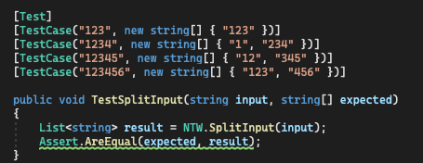

Status: Passed Third Test

Third Test

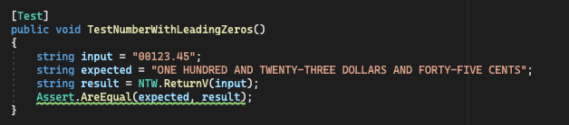

Status: Passed Third Test

Actions:  
I will fix the code on NTW.ReturnV funcJon and figure it out why the test failed and fix it.